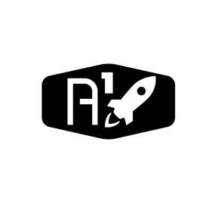

DESIGN DOCUMENT

Area : Converse Engine

Category: Feed (Piping)

TEAM: Propulsion

Nyameaama Gambrah

Engine (Abstracted)

Electrical

Electrical

Fuel Propellant Line

Oxidizer Propellant Line Line

Combustion Chamber

Injector

*P*

*P*

*P*

*P*

Pipe

5

4

3

2

1

Steel Encased

Steel Encased

MOV

MFV

Lithium-ion

Battery

Steel Encased

Steel Encased

Casing

Casing

MCU

Pressure Transducer

Pressure Transducer

Pipe

Avionics Bay

Oxidizer Inlet

Fuel Inlet